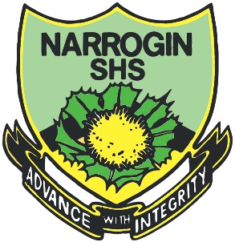

**Year 8 Science 2022**

**Task 15: Chemistry 2 Test**

**Name: ___________________**

Consider the following diagram:

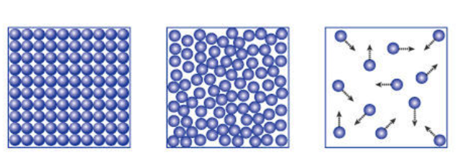

1. From **left to right** which of the following is the correct type of phase:
2. liquid, solid and gas
3. gas, liquid and solid
4. liquid, gas and solid
5. solid, liquid and gas
6. In which state of matter is the force between particles the **strongest**?

a) gas

b) liquid

c) solid

d) all of the above

1. Which of the following is an example of physical change?
   1. grinding flour
   2. burning wood
   3. photosynthesis
   4. respiration
2. What is the name given to the type of reaction when paper is burnt in air?

a) combustion

b) dissolving

c) crystallisation

d) evaporation

1. When the bathroom mirror steams up it is an example of:
2. Melting
3. Boiling
4. Condensing
5. Freezing
6. Water contains 2 hydrogen atoms bonded on to 1 oxygen atom. Water is:
7. An atom
8. A compound
9. A mixture
10. None of the above
11. Which of the following is a physical change?
12. Methane burning in air
13. Magnesium fizzing in hydrochloric acid
14. Salt dissolving in water
15. Glucose releasing energy in respiration
16. The size of the particles of a substance affects the rate of a reaction. If the particles are smaller the reaction rate will:
17. decrease
18. increase
19. stop
20. not change

Consider the following chemical and word equation:

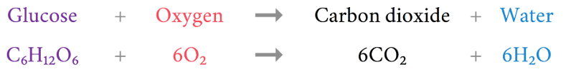

1. What is the name of this chemical reaction? They are both the same type of reaction?
2. neutralisation
3. cellular respiration
4. photosynthesis
5. condensation

Consider the following word equation:

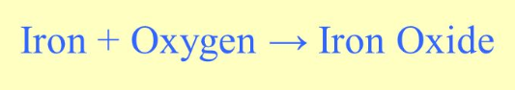

1. Which component of the reaction is the product?
2. Iron
3. oxygen
4. Iron Oxide
5. the arrow

Examine the following diagram to answer question 11

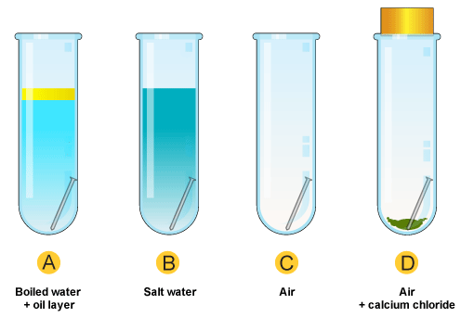

1. In which test tube would you expect to find the most rust
2. Test tube A
3. Test tube C
4. Test tube D
5. Test tube B
6. Which is an example of chemical change?
7. Hair cutting
8. Purifying water
9. Fireworks
10. Vapourisation of dry ice.
11. Look at the diagram on the right. The diagram shows a: 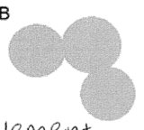
12. Molecule.
13. Element and molecule.
14. Molecule and compound.
15. Compound and element.

Examine the following diagram/graph and answer Q14 and Q15:

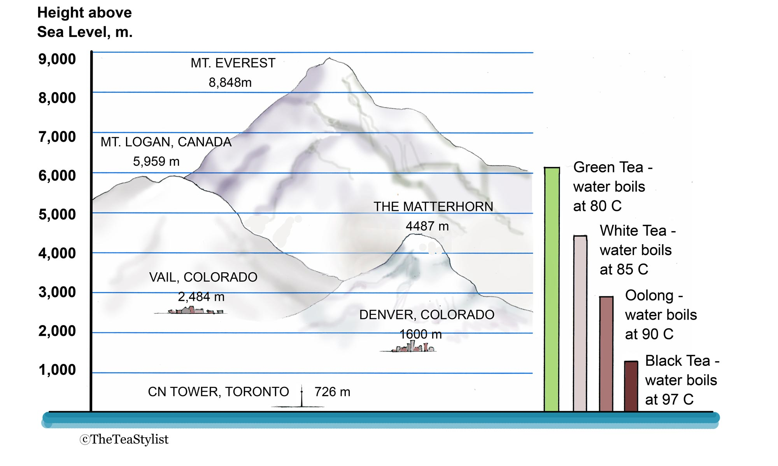

14. Which tea would reach its boiling point at the top of MT Logan?

a) Green Tea

b) White Tea

c) Oolong Tea

d) Black Tea

15. As the altitude increases, what happens to the boiling point of tea?

a) decreases

b) increases

c) stays the same

d) increases then decreases

**2022 Year 8 Science Chemistry 2 Topic Test Answer Sheet**

Name: _______________

**Section 1: Multiple Choice Section**

Circle your selection. Make it clear to the marker what your selection is.

1. A B C D
2. A B C D
3. A B C D
4. A B C D
5. A B C D
6. A B C D
7. A B C D
8. A B C D
9. A B C D
10. A B C D
11. A B C D
12. A B C D
13. A B C D
14. A B C D
15. A B C D

**M/C Marks: ______ / 15 marks**

**Section 2: Written Section 20 marks**

Answer the following questions ion the spaces provided:

1. Read the following statement and convert it to a word equation. The template is provided for you.

“In an experiment, Nitric acid and Copper react together to form Copper Nitrate and hydrogen gas”

(2 marks)

______________ + ______________ ____________+________________

1. Read the following statement and convert to a word equation. This time a template is **not** provided for you.

“In an experiment, Sodium Hydroxide and Sulphuric acid react together to form Sodium Sulphate and water.”

(2 marks)

1. The diagrams below represent the arrangement of particles in four different gases. In the space below, correctly identify each one as an element, a compound or a mixture. (Use one label twice) (4 marks) 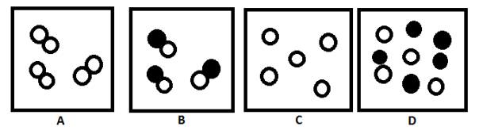

A _______________________________ B ________________________

C _______________________________ D ________________________

4. Fill in the table below. (8 marks)

|  |  |
| --- | --- |
| Element | **Symbol/Formula** |
| Helium |  |
|  | Be |
|  | P |
| Calcium |  |
|  | Cl |
|  | N |
|  | CO2 |
| Water |  |

5 List 4 signs you would look for to indicate a chemical change had occurred.

(4 marks)

1____________________________________________________________

2____________________________________________________________

3____________________________________________________________

4____________________________________________________________

**Total 35 marks**